6.6 DAX Calculations

Variables
DAX variables can help avoid code repetition and improve performance
You can create a DAX variable with the keyword VAR VariableName = {Your Expression}
You will need to return a value, using the RETURN keyword, like so:
Sales YoY Growth % =
VAR SalesPriorYear =
CALCULATE([Sales], PARALLELPERIOD('Date'[Date], -12, MONTH))
RETURN
DIVIDE(([Sales] - SalesPriorYear), SalesPriorYear)

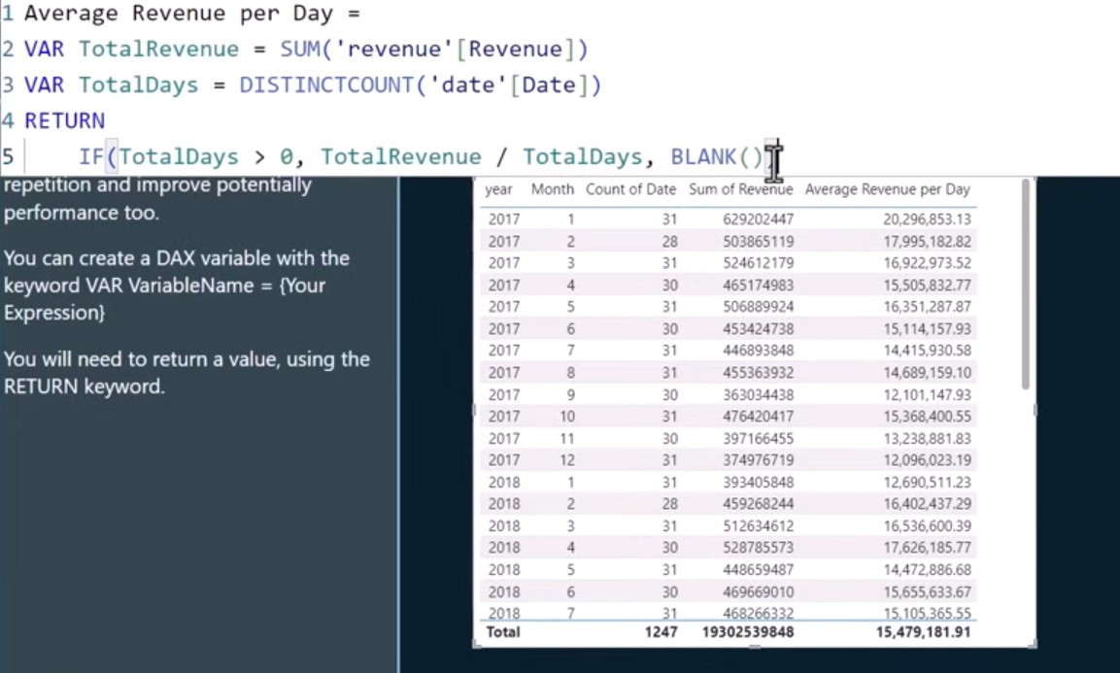

Iterators
Iterator functions in Power BI enumerate through all rows in a table, performing some calculation (depending on the iterator function you choose) and aggregating the result.
Examples include SUMX, COUNTX .
Revenue =
SUMX(
Sales,
Sales[Order Quantity] * Sales[Unit Price] * (1 - Sales[Unit Price Discount Pct])
)

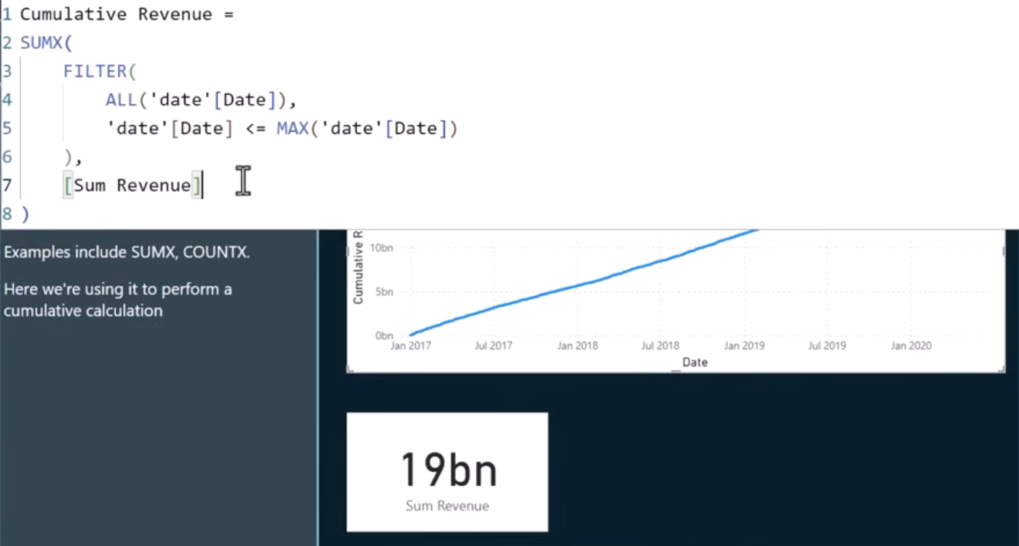

Table filtering
The FILTER function returns a table that represents a subset of another table or expression. For example:
FILTER('InternetSales_USD', RELATED('SalesTerritory'[SalesTerritoryCountry])<>"United States")
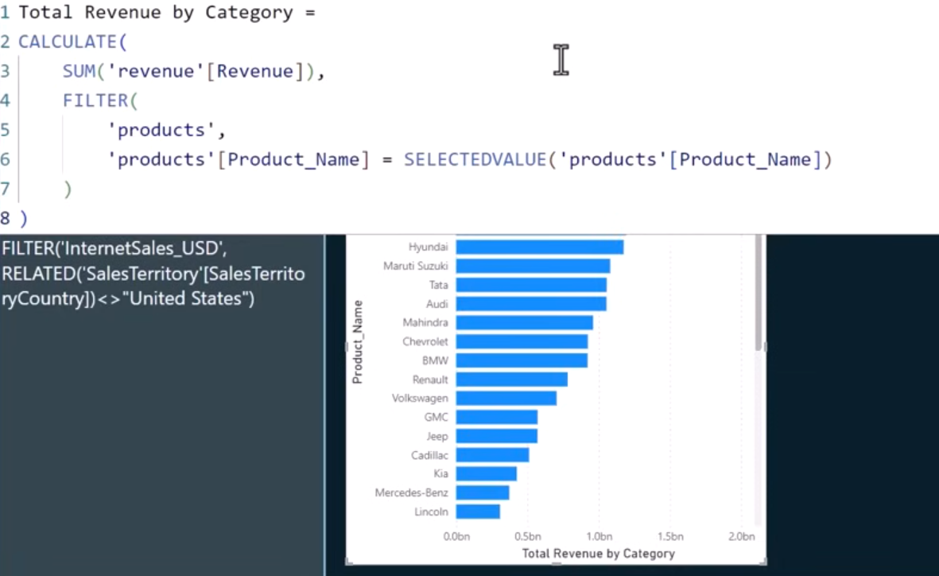

Window functions
Window functions allow you to perform calculations within a specific window of your table data.
This window can either be:
- time-based (e.g. a 3 month moving average),

- or a window of a categorical variables (e.g. average revenue for each department in a company).

- A window function can be used in combination with sort of measure like iterator.

Information functions
DAX information functions look at the cell or row that is provided as an argument and tells you whether the value matches the expected type. For example, the ISERROR function returns TRUE if the value that you reference contains an error.
Useful examples include:
- CONTAINS Returns true if values for all referred columns exist, or are contained, in those columns; otherwise, the function returns false.

- CONTAINSSTRING Returns TRUE or FALSE indicating whether one string contains another string.

- HASONEVALUE Returns TRUE when the context for columnName has been filtered down to one distinct value only. Otherwise is FALSE.

- ISBLANK Checks whether a value is blank, and returns TRUE or FALSE.

- ISERROR Checks whether a value is an error, and returns TRUE or FALSE.

- SELECTEDMEASURE Used by expressions for calculation items to reference the measure that is in context.

- USERPRINCIPALNAME Returns the user principal name.

